Homework 6 Trees Answers

1. Figure 1 shows a binary search tree into which the items Q, S, G, D, W have been inserted.

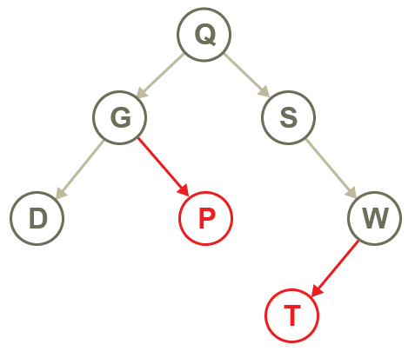

Figure 1

(a) Amend the tree to show the addition of nodes ‘P’ and ‘T’ [2]

(b) Complete the array of records below to represent the binary tree. [6]

 | left | data | right
tree [0] | 2 | Q | 1
tree[1] | -1 | S | 4
tree[2] | 3 | G | 5
tree[3] | -1 | D | -1
tree[4] | 6 | W | -1
tree[5] | -1 | P | -1
tree[6] | -1 | T | -1

2. The following items are to be inserted into a binary search tree so that they can be retrieved in alphabetical order.

mushroom, satsuma, pineapple, grape, lettuce,carrot, orange, fig, watermelon, banana, radish

(a) Draw the binary tree. [4]

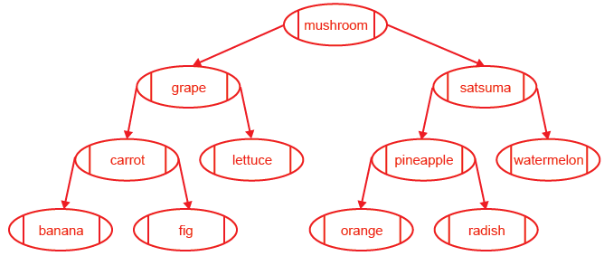

One mark for each correct level in the tree.

(b) Write down the first six nodes visited in a pre-order traversal. [3]

mushroom, grape, carrot, banana, fig, lettuce

(c) Write down the first six nodes visited in a post-order traversal. [3]

banana, fig, carrot, lettuce, grape, orange

3. Here is a binary tree.

(a) In what order have the items been inserted into the tree? [1]

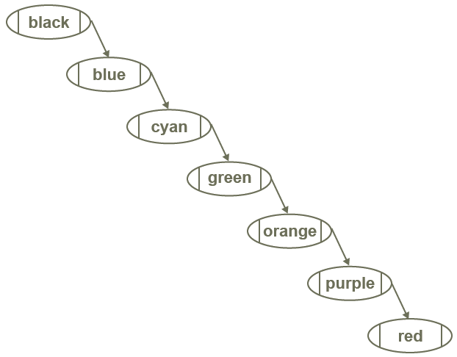

(b) What is the effect on the time taken to find a particular item in a tree, if the tree has been constructed in this way? Explain your answer. [2]

Unbalanced so slower to search. It reduces to a sequential search.

(c) A tree can be “rebalanced” so that it will give optimal search efficiency.
Draw the tree that will result from adding the nodes in the most efficient possible way.
[4]
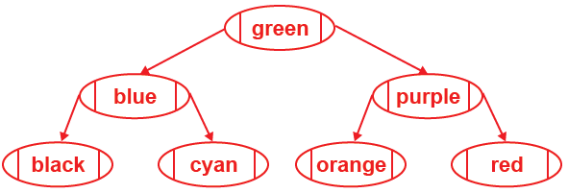

Two marks for each side of the tree.

[Total 25 Marks]

